Basic layout-

fitting on the screen. scroll not possible.

differences between find me and log in:

log in takes directly to profile page

find me starts at vehicle info: starting at the very end of the vehicle tab- benefits? update mileage? Can’t update anything else…. doesn’t save any of your appointments or services scheduled. “logging in” or checking this way erases everything? doesn’t even remember contact info…. Via phone number, different if you log in with confirmation code.

1 VEHICLE

a) Navigation arrows… not obvious. can’t see them. dots at the bottom of lists.

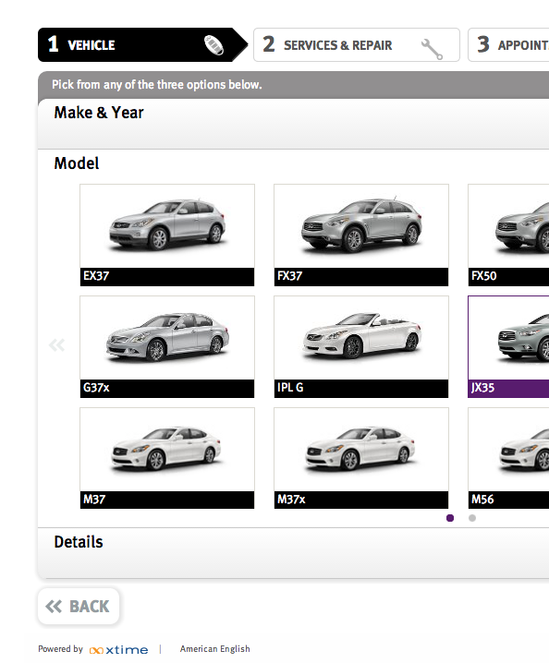

2 SERVICES & REPAIR(S) *

b) Standard/schedule 1: description in box is not useful. also its the same as factory.

c) ADD-REMOVE-MORE DETAIL(S) some way to signify that all that is in one button. you have to look at more details to perform any action.

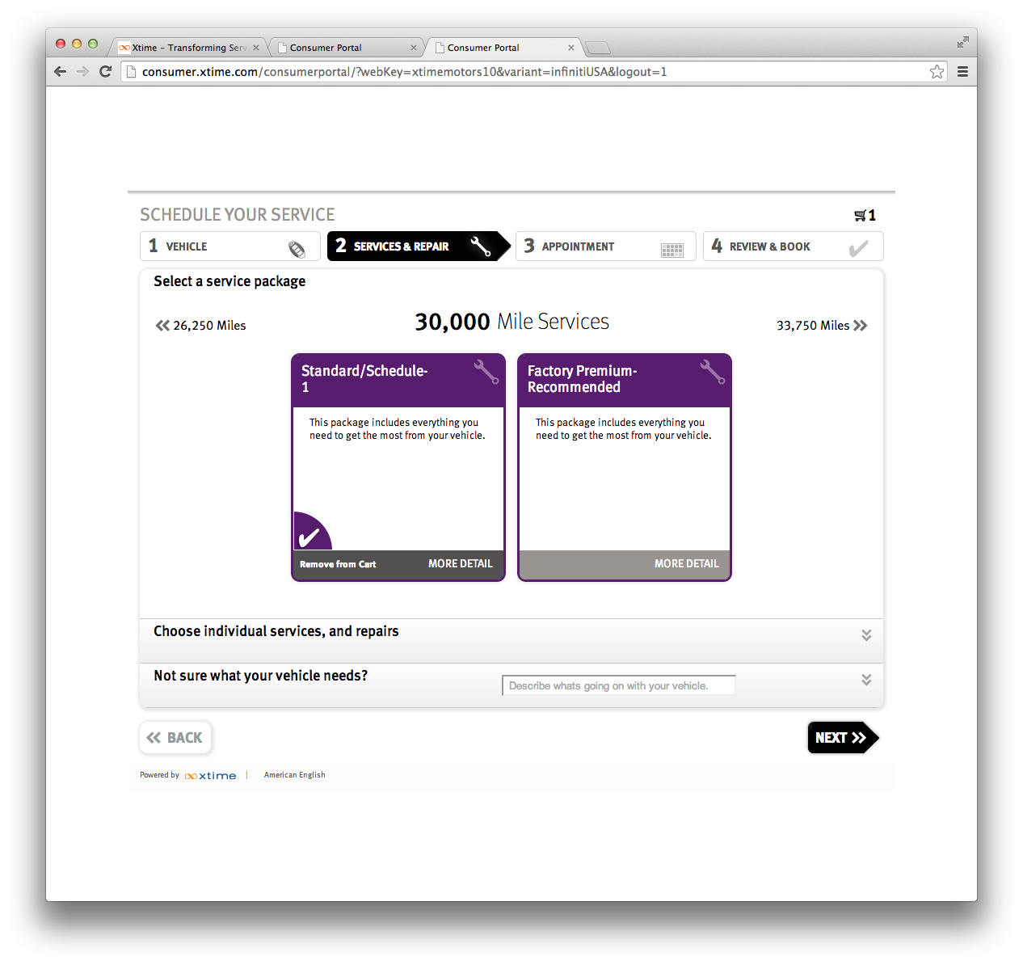

d) “Schedule” doesn’t fit on one line in the “More Detail” view.

e) ~~Looks like you can move the black bars… interesting design, not sure its the most appealing.~~

f) Didn’t know you could scroll up and down for more options: some sort of indication that there is more to view.

~~Factory Premium-Recommended: details blurb below have more info?~~ (see 1)

~~Lots of space emptiness… not necessarily bad but rearrange buttons or layout while keeping it simple and clean.~~

~~g) Whenever directed straight to the services and repairs page the service packages don’t show. have to go to vehicle and hit next. whenever hit edit from either home page, service timeline, or before booking it this isn’t working.~~

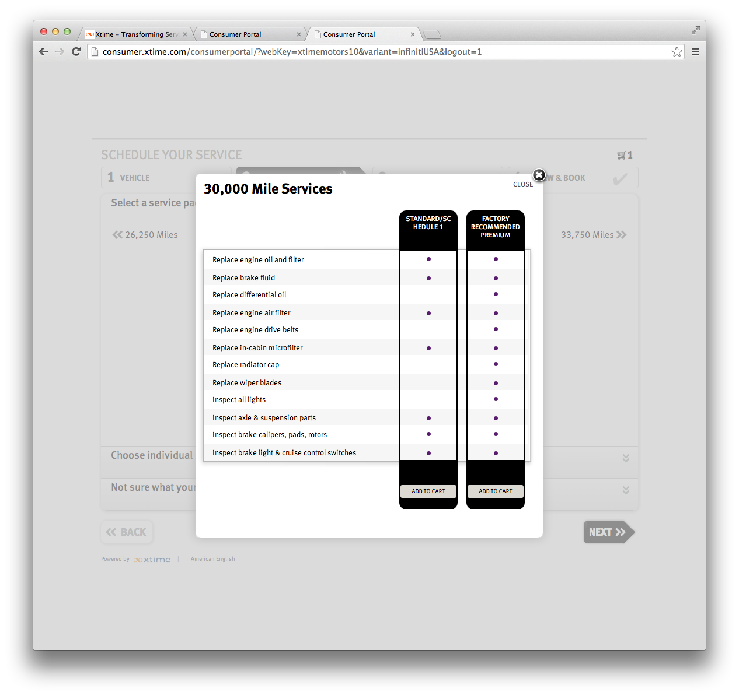

Individual services, and repairs

h) Services: more detail doesn’t actual give more details (make more like repairs details) or make add or remove button instead? It is consistent though.

i) Repairs: Details are good, but for the text box address prompt (is it suppose to be used for the customer, dealer/consultant?). More like what’s in the text box in “Not sure what my vehicle needs?” where it says “Describe what’s going on with your vehicle”.

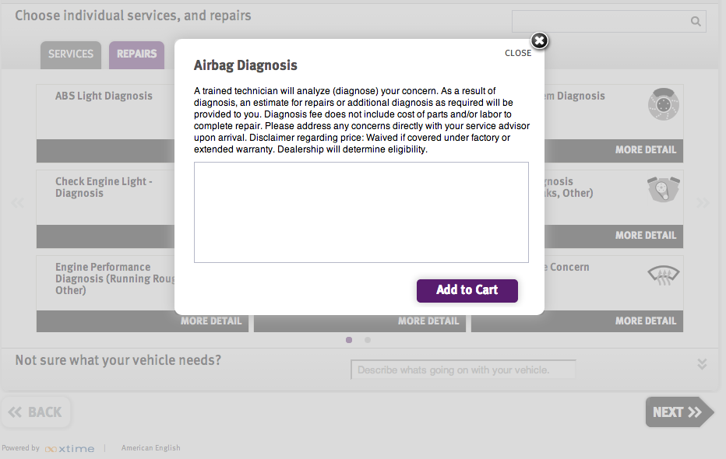

3 APPOINTMENT

j) Transportation options: valet, waiter, rental/loaner

* + - VALET- not always available, when trying to go back to edit booked appointment? need a log in which hasn’t been created yet.
    - WAITER- just wait? also not always available?
    - RENTAL- LOANER- VEHICLE:
    - Drop- off? why does it change when you select a different option. should always be drop off.

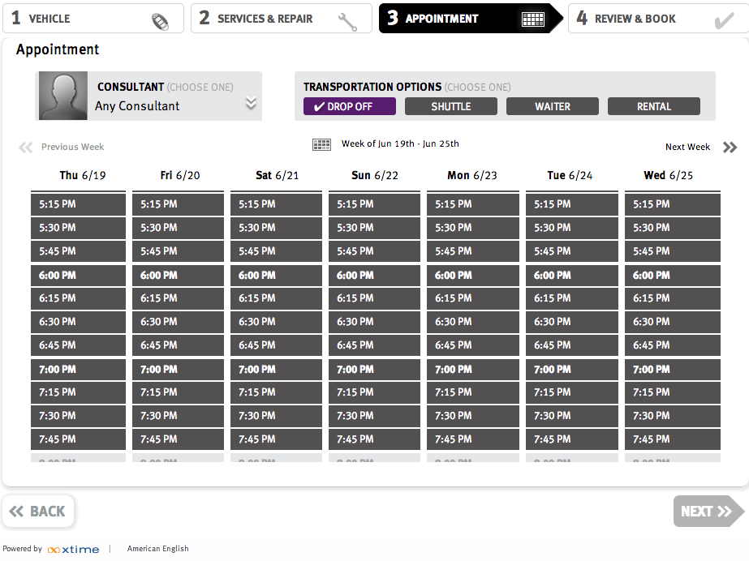

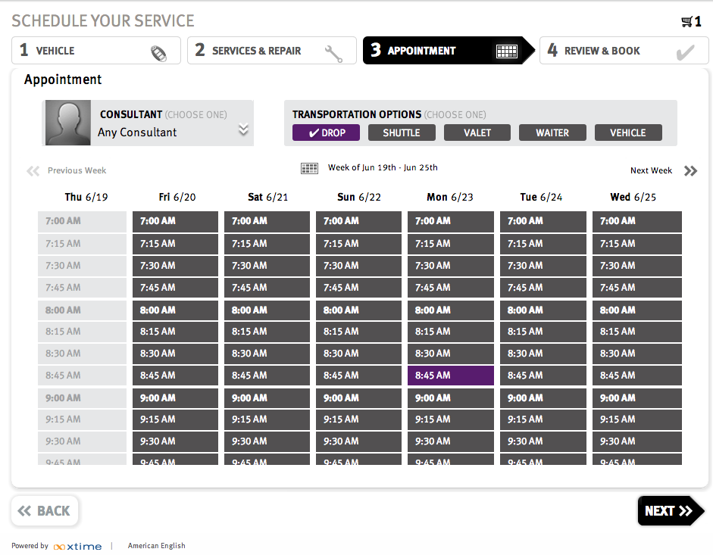

* Calendar: design. scrolling feature not the greatest.

k) the little calendar icon is very small to try

l) and view the whole month view (little drop down arrow in the pop out calendar doesn’t work).

m) also not indicated that you click on it to change via a month view. (the title of what week is currently being viewed isn’t greatly formatted makes it seem like the calendar button isn’t relevant )

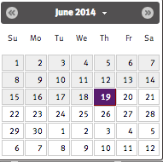

l

k

CONFIRMATION PAGE

_ more emphasis on “~~registering~~” or making an account. not as inviting to register- as to create login/sign up… describe what it entails. more than just reminders. edit/update scheduled appointments, keep track of service history, service other cars?....

way to home page again? Or some contact information

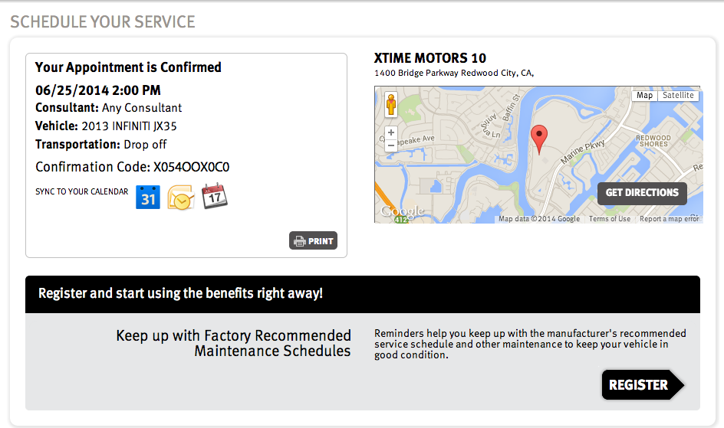

Main home profile page:

n) update mileage- isn’t obvious, more of a text box or button, something that looks like it can be edited.

o) View service history= to view service timeline?

p) view service history doesn’t show scheduled upcoming appointments on that page or timeline. (Compile so if you have multiple cars can look at all the service timelines together? or in one view to compare or just convenient option)

q) Notification box: doesn’t update right away. If you change appointment day/time when directed back to page the service appointment hasn’t changed in the notifications yet.

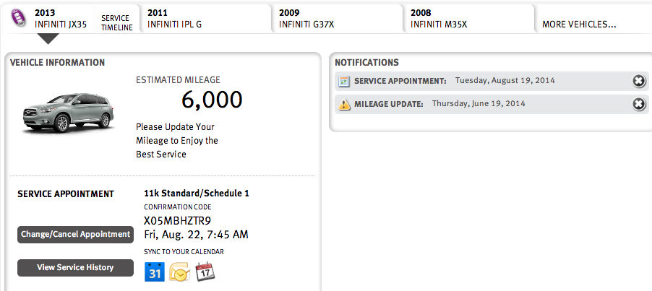

n

q

o

Settings- My details: if you make an update have to click the close button to save changes… should be a close and save button. Overall in settings should there be a save button? confusing if just close.

In vehicle details: drop downs are all faded out, why even have them, just give possibility to add license and update mileage? Just annoying/frustrating?

My details: preferred contact method… but what if you set reminders to email and phone? what does the address lead to? send mail reminders? advertisements? this is the only place to input it… just to have it on file?

~~Whenever editing: what if you want to cancel. also can’t see what you are currently scheduled for. if you hit edit its like starting over.~~

When editing from Find Me- only holds your car information, doesn’t remember the past service info, not really an edit?

Any place to contact someone if you have questions?

shopping cart: should be able to click on what’s in cart? to view, or be brought to that page to change/update?

Service Timeline:

Doesn’t show upcoming scheduled appointments.